Semester 1 Term 2  2015 | Year 9  Investigation 2  Statistics  Calculator Allowed | 

Name:_____________________ Class:_________________ Mark: ___/32

Mrs Green has two year 9 math class and she wanted to work out which of her math classes did better on their recent exam. The table below shows the results of each of Mrs Green’s classes.
Class A | 24 | 45 | 62 | 82 | 29 | 35 | 46 | 38 | 51 | 67 | 79 | 48 | 55
 | 33 | 50 | 70 | 51 | 64 | 78 | 83 | 46 | 52 | 47 | 68 | 53 | 64
Class B | 82 | 60 | 41 | 46 | 50 | 52 | 62 | 63 | 78 | 85 | 85 | 79 | 78
 | 72 | 50 | 35 | 28 | 61 | 61 | 73 | 83 | 84 | 79 | 74 | 86

- [5 marks]
Represent the results for each of the classes on a back to back stem and leaf plot.

Class A | 24 | 45 | 62 | 82 | 29 | 35 | 46 | 38 | 51 | 67 | 79 | 48 | 55
 | 33 | 50 | 70 | 51 | 64 | 78 | 83 | 46 | 52 | 47 | 68 | 53 | 64
Class B | 82 | 60 | 41 | 46 | 50 | 52 | 62 | 63 | 78 | 85 | 85 | 79 | 78
 | 72 | 50 | 35 | 28 | 61 | 61 | 73 | 83 | 84 | 79 | 74 | 86

- [8 marks]
Determine the measures of spread and measures of centre (range, mean, median and mode) for each class.

Class A  Mean=  Median=  Mode=  Range= |  | Class B  Mean=  Median=  Mode=  Range=

- [6 marks]
Group the test results for each class in the following frequency tables.

Class A |  |  |  | Class B
Class interval | Tally | Frequency |  | Class interval | Tally | Frequency

- [5 marks: 4,1]

- Represent the results for Class A in a histogram

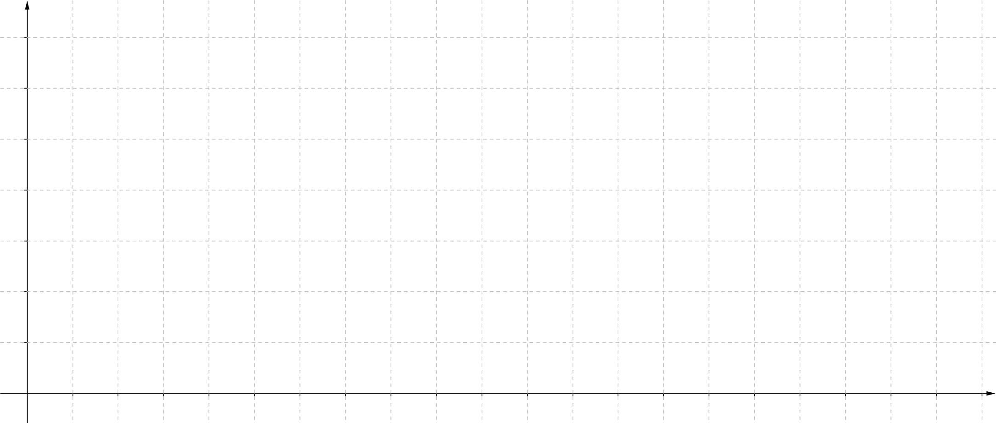
- Describe the shape of the histogram for class A

- [5 marks: 4,1]
- Represent the results for Class B in a histogram


- Describe the shape of the histogram for Class A

- [3 marks]
Which class did better in the exam? Justify your answer.
(Hint: Use your answers from questions 1, 2, 3 and 4)

